Title Page

Classification:

Title: Environmental Factors of Honey Bee Loss: Do Neonicotinoids Matter?

Author Affiliation:

Authors: Kathy Baylis, Guyu Ye, Jai Holt, Dennis vanEngelsdorp, & the Bee Informed Partnership

Keywords: honeybee health, neonicotinoids
Abstract

Since 2006, beekeepers around the world have reported unusually high rates of honeybee colony loss. In the last two years, attention has turned to neonicotinoids as a potential factor in honeybee disease and mortality. While fatal at high doses, neonicotinoids are primarily used as seed treatments, and researchers debate whether and how honeybees are exposed to these pesticides in regular conditions in the field. We combine unique geocoded data on pollen samples across 40 US states over the past 4 years with crop data to ask where and when we observe evidence of neonicotinoid exposure in the hive. We use these data to compare hypothesized exposure pathways. Second, we explore whether those colonies where neonicotinoids are found in the pollen have higher levels of disease, which might suggest that neonicotinoids affect colony health. We find some evidence of bees’ exposure to neonicotinoids under normal cropping condition. While found in only a small percent of colonies, neonicotinoid contamination corresponds to planting seasons of neonic-treated crops, such as corn. The prevalence of Nosema is higher in neonic-contaminated apiaries than non-contaminated apiaries.

Significance Statement

The EU recently banned the use of some neonicotinoids due to their suspected effect on honeybee heath and calls are increasing in the United States for a similar regulatory response. The scientific literature is more cautious in terms of the possible effect of neonicotinoid seed treatments in part due to the question on whether and how honeybees are exposed to the pesticide in regular field conditions. The existing scientific literature has explored the effect of neonicotinoids using lab and controlled field studies. To our knowledge, this is the first study using field data from a large geographic sample of sites to test whether and when bees are exposed to neonicotinoids in a standard commercial apiary setting, and to examine whether exposure is correlated with increased prevalence of disease.

Honey bees are valuable assets for the United States and the world. A third of all food is depended on pollinators. This pollination service adds approximately $15 billion in crop value in the United States every year (USDA 2013). Harvested honey produced by managed honey bee operations with 5 or more colonies was worth approximately $287 million in 2012 (USDA NASS 2013), and other byproducts including beeswax and bee pollen have greatly improved people’s everyday life. However, the availability of managed honey bees has fallen and is under threat from colony loss. The Report on the National Honey Bee Health Stakeholders Conference in 2012 shows that the supply of bees has declined from about 6 million colonies in 1947 to 4 million in 1970, to 2.5 million in 2012. In particular, since 2006, when unexplained losses of honey bee colonies began to be reported as Colony Collapse Disorder (CCD), beekeepers have lost 30-90% of their honey bees every winter (National Honey Bee Health Stakeholders Conference 2012). Even though the winter losses from 2013 to 2014 are among one of the lowest in eight years, two-thirds (66%) of beekeepers still exceeded their acceptable loss rate of 19% (Lee, et al. 2014).

While the causes of the decline are still not completely understood, parasites such as Varroa mites (Guzman-Novoa, et al. 2010) and Nosema (Higes, et al. 2008) are known contributors to colony loss. Varroa destructor, a virus-transmitting parasite that was introduced to the United States in the mid 1980s, has been identified as the most detrimental pest to honey bees. Nosema is a gut parasite that harms bee colonies (USDA 2013). Other factors including colony management practices, poor nutrition, pests and some socio-economic factors are also potential contributors to bee loss (Lee, et al.2014).

Recently, attention has turned to several pesticides as a possible contributor to colony decline. In particular, a class of nicotine-derived pesticides, neonicotinoids (neonics), including Acetamiprid, Clothianidin, Dinotefuran, Imidacloprid, Thiacloprid and Thiamethoxam, have been implicated as a cause of bee deaths. Neonics were introduced in the late 1990s to replace the more toxic mass spraying of organophosphate and pyrethoid pesticides (Entine 2013). Most neonicotinoid pesticides protect plants from insects and are water-soluble and slowly break down in the environment (Hunt, 2012). In the United States, neonicotinoids are currently used on about 95 percent of corn and canola crops, the majority of cotton, sorghum and sugar beets, about half of all soybeans, and a vast majority of fruit, vegetable and grain crops (Grossman, 2013). In particular, the use of Clothianidin on corn in Iowa alone has almost doubled between 2011 and 2013 (USGS 2014).With the popular adoption of neonicotinoid seed treatments in current farming practices, there is a growing concern that neonics’ potential negative impact on bees might harm the world’s food production and supply. Therefore, the European Union had declared a 2-year ban on three neonicotinoids (Clothianidin, Imidacloprid and Thiametoxam) in 2013 as a precautionary action (European Commission 2013). While similar calls for a ban exist in the United States, the U.S., however, chose to continue the use of neonicotinoids due to a lack of proof of their harmful effects.

Some researchers suggest that under typical crop conditions, bees are not exposed to high enough doses of neonicotinoids to cause health concerns. According to research conducted by Dr. Gus Lorenzo from University of Arkansas, neonicotinoids are not expressed in the reproductive part of corn, soy, or cotton plants in high enough levels to harm honey bee health (Lorenzo 2014). In fact, no neonicotinoids were detected in cotton and soy flowers. He therefore concludes that neonicotinoid seed treatments are not harmful to bees in terms of exposure to contaminated nectar and pollen. Using 2 groups of 8 honeybee colonies, Faucon et al. demonstrate that bees’ chronic exposure during the spring and summer to crops treated by neonicotinoids at the highest recommended rate does not affect the mortality of overwinterized colonies (Faucon et al. 2005, Cutler and Scott-Dupree 2007). The United Kingdom Department of Environment, Food and Rural Affairs compiled evidence on neonicotinoid exposure to honey bees and concluded that findings suggest that neonicotinoids do not harm bees under normal circumstances and that laboratory studies on the sub-lethal level of neonicotinoids created extreme situations that are not applicable to real world conditions (United Kingdom Department of Environment, Food and Rural Affairs 2013).

In contrast, many researchers and beekeepers argue that bees are exposed to neonicotinoids and that neonicotinoids have a negative impact on honeybee health. Using the liquid chromatography-tandem mass spectrometry (LC/MS-MS) analysis, Dr. Krupke has found that bees’ exposure to neonicotinoid compounds happen in several ways throughout the foraging period, especially during the planting season of treated maize (Krupke, 2012). Dr. Greg Hunt from Purdue University finds an extremely high concentration of Clothiandin and Thiamethoxam in talc, which is a seed treater that helps with seed flow during planting with an air seeder and improves seed spacing. A gram of talc containing 1.0% Clothianidin could theoretically kill a million bees if they ingest it, and could threaten about half as many bees if they come into contact with the dust (Laurino et al. 2011; Tremolada et al.2010). He thus concludes that bees may be exposed to a sub-lethal level of pesticides throughout the growing season even though the greatest danger occurs during planting. The popular adoption of neonicotinoid seed treatments which are persistent in plants makes it very difficult for bees to avoid exposure to these toxic chemicals. A controversial study by Dr. Chensheng Lu from Harvard University suggests that even sub-lethal exposure to neonicotinoids would impair honey bee winterization and thus lead to colony loss (Lu, et al. 2014). Even though Lu claimed that he had replicated CCD, there was not any support from prominent entomologists. Instead, several entomologists have argued that his sample size was too small to reach a conclusion and that he might have killed the bees himself by overdosing in a cold winter (Entine 2014, Helman 2013).

Recent articles have also addressed concerns over the potential negative impact of neonicotinoids on bees. Paul Towers, from the Pesticide Action Network said that even though the amount of pesticide in the pollen of neonic-treated plants might be too small to kill bees, it was enough to disorient and reduce the ability for them to get food and communicate (Charles, 2013). Even though Bayer CropScience, the biggest seller for neonicotinoid pesticides claimed that neonics have been proven safe by most studies, they are taking precautionary action to work on a new system for planting corn that will reduce neonic release (Charles, 2013). Studies have also shown that the negative effect of neonicotinoids are not limited to bees; they harm birds, mammals, worms and aquatic insects as well (Thomson, 2014). According to research by USGS, neonics have been found in surface water throughout the Midwest, where corn and soybean production are most prevalent (USGS 2014). This contamination in waterways might translate into a deteriorated heath of other creatures as well.

Unlike previous work that uses lab and limited field experiments to explore the relation between neonicotinoid seed treatments and honeybee health, we use a large number of samples collected from 40 US states over 4 years to first ask whether we observe evidence of neonicotinoid exposure in a real world crop setting and examine which times of year and which nearby crops are correlated with evidence of this exposure. In addition, we ask whether we observe any evidence that exposure to neonicotinoids is correlated with higher disease loads. We follow on the work of Jai Holt (2014) who finds some suggestive results on landscape factors that affect honey bee morbidity. With geocoded data, she observes that colonies located near corn and soy, two crops commonly treated by neonicotinoids, are correlated with higher Nosema loads during planting. No clear evidence on the correlation of Varroa mites and locations is found. Our goal is to examine whether there are significant differences in the types of nearby crops, time and disease levels near neonic-contaminated apiaries compared to the ones where contamination is not found.

Materials and Methods

For this study, we merge the USDA Animal and Plant Health Inspection Services (APHIS) Survey of Honey Bee Pests and Disease with NASS Cropscape data by geographic coordinates and year. We specifically focus on those colonies that are not migratory to ensure that the nearby cropscape appropriately represents the landscape for the time the sample was taken (Holt 2014). We consider apiaries as migratory if beekeepers list their operations as migratory or pollination and non-migratory otherwise. However, if the type of operation is listed as both stationary and pollination, we consider this apiary as non-migratory as well.

The USDA APHIS conducts the Honey Bee Pest and Disease Survey as a means of identifying pests, pathogens, and disease affecting honey bees in the United States. This data set contains information on apiary samples collected from 2009 to 2014 throughout the United States. Forty states with 1853 samples are in the data set. In each sampled apiary, at least 8 colonies are tested for a number of diseases and pests. Not all samples are tested for pollen residue; 676 samples have pollen sample results. Since there is no crop information for samples in 2014 or Hawaii, we exclude these areas from our analysis. Based on the migratory proxy Holt built (2014), we exclude the migratory colonies as well to avoid bias. This approach leaves us with 526 samples over 5 years.

We map the sampled non-migratory apiaries in APHIS onto NASS cropscape data determine the crops grown within a 2-mile radius of each apiary. The resolution of these data is set at 30 meters squared per pixel (USDA NASS n.d.). We extract the crop area within two miles of each apiary as this is vicinity in which bees typically do most of their foraging (Eckert, 1933). We then aggregate the crop and land cover based on the land cover class definitions (USGS 2012) The top land cover in most areas are forested uplands, which includes deciduous forest, mixed forest and evergreen forest. Major crops including corn and soybeans surround many apiaries, especially in the Midwest. Fruits including oranges and apples surround several apiaries in the southern states, such as Florida and California.

We compare the crops and regions within 2 miles of colonies that are contaminated with the landscape near ones that are not. We calculate the percentages of different kinds of crops within 2 mile buffer and find out the top 10 aggregated land covers or crops near each type of apiary. Their means are examined to see if there are significant differences in the percentages of certain crops nearby between the two types of apiaries.We look at the months and states where neonicotinoid contamination is detected to determine the most likely pathways of contamination. We then repeat this analysis by region to take local heterogeneity into account. The USDA regions are selected to increase the comparability of the studies. Another analogous analysis is also made in Corn Belt region. This analysis shows us how the planting time and region of corn, a crop commonly treated by neonics, could be correlated with neonic contamination.

We use two morbidity factors as indicators of bee health: Varroa mite load and Nosema parasite load. We explore whether the neonicotinoid-contaminated colonies have a significant higher prevalence of Varroa mite load and Nosema load than non-contaminated colonies. We first compare the overall virus prevalence in these two types of colonies. Since some bee researchers suggest that both Varroa and Nosema may only be harmful at threshold levels (vanEngelsdorp, Tarpy, et al. 2013, Genersch, et al. 2010), we conduct an analogous analysis on the colonies with disease loads of above threshold levels (3 mites per bee for Varroa destructor and 1 million spores per bee for Nosema parasite) to examine on the differences in the prevalence of diseases in these unhealthy colonies.

Last but not least, we conduct case studies for three regions (USDA Census Region 1, 3 and the Corn Belt) to capture the potential bias from our general analysis. USDA Region 1 includes northeastern and Midwestern states, and USDA Region 3 includes all the southern states except for California and Arizona. We compare the prevalence of diseases and types of crops in neonic-contaminated apiaries and non-contaminated apiaries to examine potential differences. Due to a small number of neonic-contaminated apiaries, analyses in other regions are not feasible.

Results and Discussion

Region and Time

Neonicotinoids (Acetamiprid, Clothianidin, Dinotefuran, Imidacloprid, Thiacloprid and Thiamethoxam) contamination in non-migratory colonies was detected in 13 out of the 40 states sampled from 2010 to 2013. Thirty out of 526 sampled apiaries had pollen contaminated by neonics, and 6 were contaminated by more than one neonicotinoid. Neonicotinoids were found in 10 colonies in 2011, 17 in 2012 and 3 in 2013. Among all the States sampled, Florida and Nebraska have the largest numbers of neonicotinoid-contaminated apiaries.

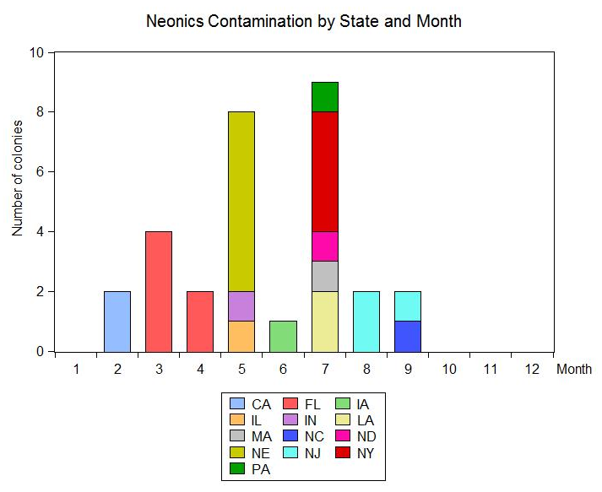
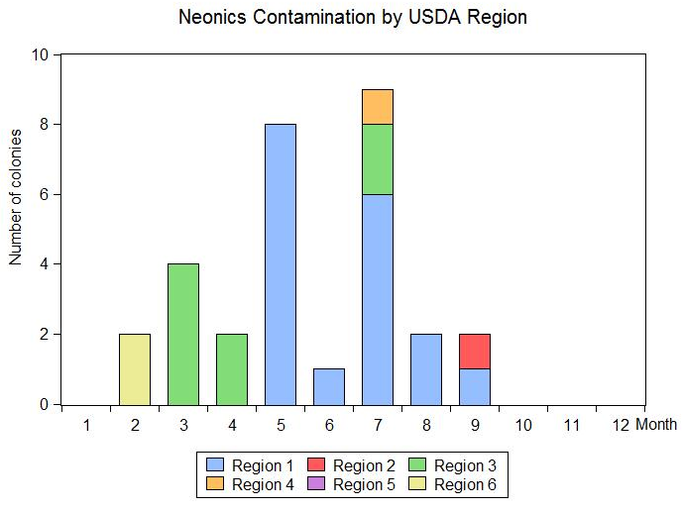
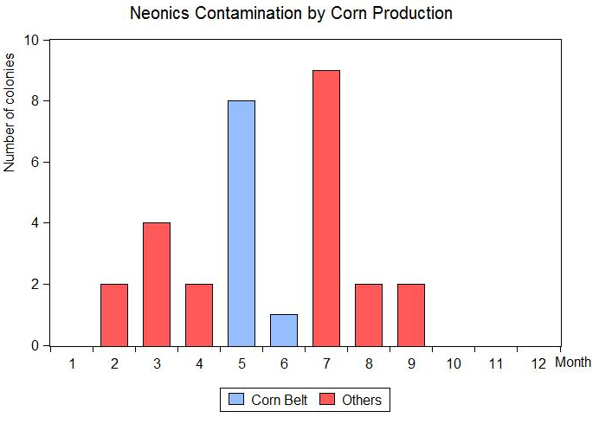
Figure 1
Figure 2
May, July and March are the top three months when neonicotinoids contamination is detected. Nine out of 11 or 82% of apiaries contaminated during the corn and soybean planting seasons (from April to June) are in the corn belt. In February, both contaminated colonies are from California. In March, all 4 contaminated colonies are in Florida. In June, one contaminated colony is detected in Iowa and in July, more states are reported to have contaminated colonies. In August and September, neonic contamination is detected in New Jersey and North Carolina. This shows a trend of neonicotinoid contamination going from the southern part of the country, such as California and Florida, to the Midwest like Nebraska and Illinois, then to colder states including North Dakota and New York, and eventually back to warm states like New Jersey and North Carolina. If we look at the number of contaminated apiaries by USDA region, it is evident that most of the contaminated apiaries were detected in northeastern and Midwestern states (USDA region 1) and the southern coastal states (region 3). No colonies were detected with neonicotinoids contamination from October to January.
Figure 3

Cropscape Analysis

We use NASS cropscape data from satellite imagery to determine the crops and other ground cover in a 2 mile radius of the tested apiaries. We compare the ground cover around the contaminated and non-contaminated apiaries to test whether there are significant differences between the percentages of any crops (see Table 1). Forested upland, which includes deciduous forest, mixed forest and evergreen forest, makes up an average of 26.7% of the landscape in the 2 mile buffer around non-contaminated apiaries, which is 130% higher than the 11.5% average within the 2-mile buffer near neonic-contaminated apiaries. Thus, we observe a negative association between neonic contamination and the percentage of deciduous forest, mixed forest and evergreen forest nearby. The percentage of oranges near neonic-contaminated apiaries is approximately 5.7%, which is significantly higher than its percentage of 0.06% near non-contaminated apiaries. This finding is because 8 out of 20 (40%) of neonic-contaminated apiaries are in California and Florida where oranges are mostly grown and neonics are commonly applied to citrus to prevent the spread of Huanglongbing (HLB) or citrus greening (Miller, 2014). The percentage of corn near neonic-contaminated apiaries is 12.7% of the landscape, or 66% higher than near non-contaminated apiaries, indicating a positive association between neonics contamination and percentage of nearby corn land. This result is expected as corn is one of the commonly treated crops by neonicotinoids.

Table 1:
 | Average Mean | Neonics Mean | No Neonics Mean | t-stat | p-value
Forested Upland | 25.83 | 11.53 | 26.69 | -3.28*** | 0.00
Developed | 17.70 | 20.16 | 17.55 | 0.64 | 0.52
Grasslands | 16.47 | 16.07 | 16.49 | -0.16 | 0.90
Corn | 7.97 | 12.73 | 7.68 | 2.20** | 0.03
Soybeans | 5.74 | 6.63 | 5.69 | 0.50 | 0.62
Wetlands | 5.89 | 10.68 | 5.60 | 2.53** | 0.01
Shrubland | 4.69 | 1.75 | 4.87 | -1.35 | 0.18
Other Hay/ Non-Alfalfa | 2.29 | 1.82 | 2.32 | -0.51 | 0.61
Alfalfa | 1.73 | 1.65 | 1.74 | -0.11 | 0.92
Oranges | 0.38 | 5.74 | 0.06 | 7.43*** | 0.00

* significant at p<0.10; ** significant at p<0.05; *** significant at p<0.01

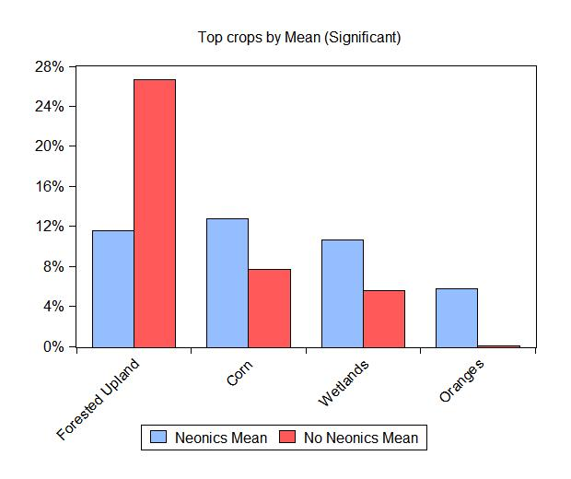
While not significantly different, we do observe evidence that developed areas and soybeans are slightly more prevalent near neonic treated apiaries. Grasslands, shrubland, other hay and alfalfa all have negative t-statistics, indicating their negative correlation with neonics contamination. Both treated and non-treated apiaries have relatively high percent of nearby grasslands, wetlands and shrublands, for a total of 43% of natural area around contaminated apiaries and 54% of natural area around non-contaminated apiaries.

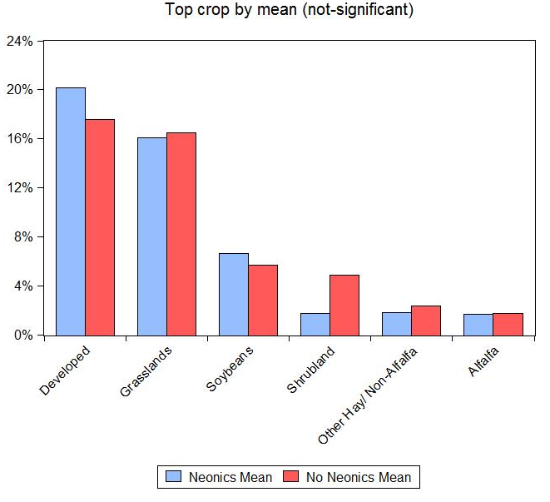
Disease Analysis
Figure 4
Figure 5

For the non-migratory apiaries where neonicotinoid contamination was not found, the mean value of Varroa destructor is 5.55 mites per 100 bees (see Table 2), which is greater than the threshold level of 3 mites per 100 bees, above which bees tend to be weaker and more susceptible to diseases (vanEngelsdorp, Tarpy, et al, 2013, Genersch, et al. 2010). Among the 229 observations with results on the disease, 133 have a Varroa level of above 3.00 mites per 100 bees, making up 58.08% of the sample. For neonicotinoid-contaminated apiaries, the mean value of Varroa destructor is 4.40 mites per 100 bees, which is also above the threshold level but below the average disease level in non-contaminated apiaries. Among the 20 observations, only 7 of them (35%) exceed the threshold level for Varroa destructor.

Table 2:

 | Count | Mean | T-stat | Chi-Squared |  | Count | Mean | T-stat | Chi-Squared
Varroa mites (per 100 bee) - contaminated | 20 | 4.40  (6.36) | 0.84 | 3.77 | Nosema - contaminated | 20 | 0.50  (0.81) | -0.81 | 28.38 ***
Varroa mites (per 100 bee) - non-contaminated | 229 | 5.55  (5.81) | 0.84 | 3.77 | Nosema - non-contaminated | 230 | 0.31  (1.04) | -0.81 | 28.38 ***

* significant at p<0.10; ** significant at p<0.05; *** significant at p<0.01

The mean value of Nosema load in apiaries that are not contaminated by neonictinoids is 0.31 million spores per bee, which is well below the threshold level of 1 million spores per bee. Among the 230 observations, 18 of them (7.83%) have a higher Nosema load than the threshold level. The mean value of the Nosema load in neonicotinoid-contaminated colonies is 0.50 million spores per bee, and 3 out of 20 observations (15%) have a higher Nosema load than the threshold level.
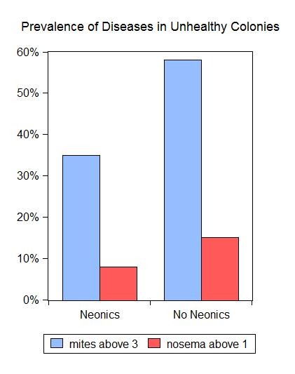
From the t-tests for the amounts of Varroa mites and Nosema load in neonicotinoid-contaminated and non-contaminated colonies, we can see that the difference in Nosema loads is significant at 1% level. This is consistent with Dr. Pettis’ result that exposure to undetectable levels of neonicotinoid pesticides gives bees significantly higher Nosema loads (Pettis et al., 2012). No significant differences in the level of Varroa mites is detected, which is consistent with Holt’s result (Holt, 2014).

Some studies have shown that both Varroa and Nosema may only be harmful at threshold levels (vanEngelsdorp, Tarpy, et al. 2013, Genersch, et al., 2010). If we only examine the colonies with disease level of above threshold levels (3 mites per 100 bees for Varroa mites and 1 million spores per bee for Nosema), we still find no significant difference in either disease between neonicotinoid-contaminated colonies and non-contaminated ones. From the normal distributions of these colonies, we can see that colonies contaminated by neonicotinoids have a larger mean of Varroa destructors while a smaller mean of Nosema than non-contaminated ones. This result might be a consequence of the small number of samples for colonies with high disease levels.
Figure 6
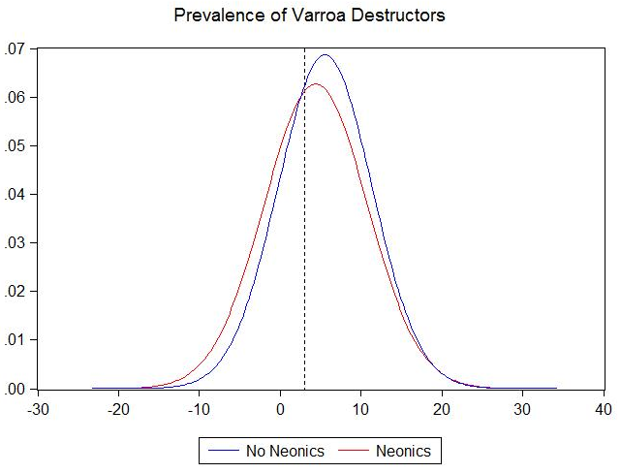
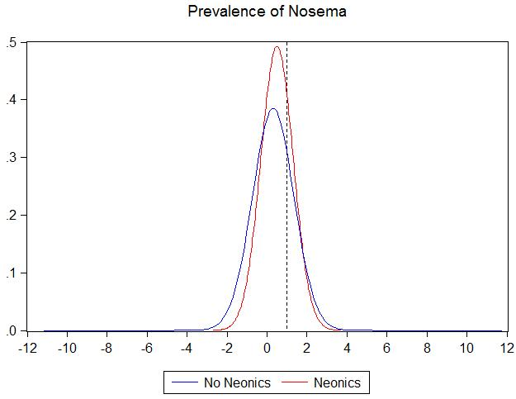

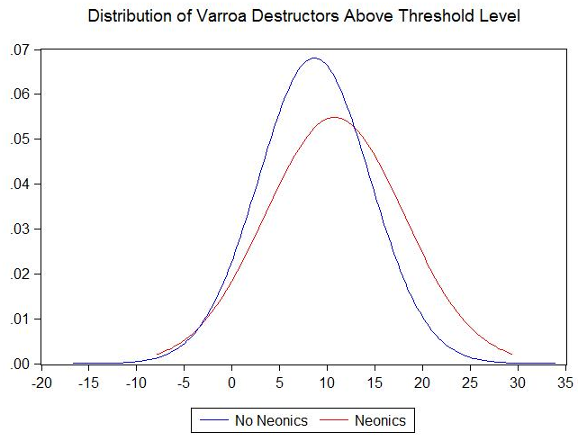
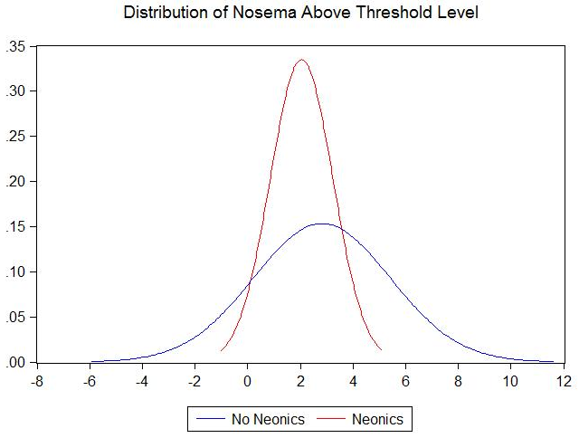

Figure 7

Regional Analysis

Readers may rightly be concerned that differences in climate, soils and other characteristics may be driving our landscape results, so we next separately consider the results by region, to ensure we compare contaminated and non-contaminated apiaries facing similar conditions. Due to the discrepancies in temperatures and crop planting time among apiaries sampled, we look at certain regions individually to capture the correlation between crops and neonic contamination. We focus on the northeast and Midwest (USDA Region 1), Florida and California (USDA Region 3) and the corn belt given that these regions house the majority of the neonic contaminated apiaries.

USDA Region 1:

This region is made up of Northeastern part and some Midwestern part of the United States including New York, New Jersey, Wisconsin, Ohio, Michigan, Illinois and etc. 8 out of the contaminated colonies are reported in May, 1 in June, 6 in July and 3 in August and September.

Table 3:
 | Count | Mean | t-stat | p-value | chi-squared
Mites Neonics | 9 | 6.03  (8.35) | 0.23 | 0.82 | 1.6
Mites No Neonics | 80 | 5.53  (5.89)
Nosema Neonics | 9 | 0.54  (1.09) | 0.51 | 0.61 | 0.38
Nosema No Neonics | 81 | 0.32  (1.24)

From Table 3, we can see that the levels of both Varroa mites and Nosema are higher in colonies that are contaminated by neonicotinoids. Even though the differences are not significant for either disease, a positive correlation between neonics contamination and prevalence of these diseases is evident.

Table 4:

 | Neonics | No Neonics | t-stat | p-value
Corn | 20.35 | 15.69 | 1.27 | 0.21
Developed area | 20.18 | 17.34 | 0.56 | 0.57
Forested upland | 17.82 | 25.69 | -1.68 | 0.1
Grasslands | 13.78 | 12.42 | 0.48 | 0.63
Soybeans | 9.46 | 10.63 | -0.4 | 0.69
Wetlands | 5.72 | 5.28 | 0.2 | 0.85
Alfalfa | 2.09 | 2.09 | 0 | 1
Other hay/ Non-alfalfa | 2.07 | 2.87 | -0.52 | 0.61
Apples | 1.56 | 0.17 | 3.54 *** | 0
Shrubland | 1.11 | 0.98 | 0.24 | 0.81
Winter wheat | 0.65 | 1.18 | -0.97 | 0.33
Barren | 0.53 | 0.17 | 2.59 ** | 0.01

In addition, there are significantly more apple orchards as well as barrens near neonic-contaminated apiaries, as shown in Table 4. Corn also has a positive correlation between neonics contamination. Since both apples and corn are commonly treated by neonicotinoids, this result shows neonics treatment is positively correlated with neonics contamination in nearby apiaries, implying bees’ exposure to neonicotinoids through crops.

USDA Region 3:

USDA Region 3 is made up of southern states, including Florida, Louisiana, Texas and etc. 4 colonies are contaminated in March, 2 in April and 2 in July.

Table 5:

 | Count | Mean | t-stat | p-value | chi-squared
Mites Neonics | 8 | 3.97  (4.49) | -0.81 | 0.42 | 4.33
Mites No Neonics | 44 | 5.11  (3.52)
Nosema Neonics | 8 | 0.62  (0.58) | 2.28* | 0.03 | 9
Nosema No Neonics | 44 | 0.18  (0.49)

Table 5 shows a significantly higher mean of Nosema loads in neonic-contaminated apiaries at 10% significance level. No significant difference in Varroa mites is detected.

Table 6:
 | Neonics | No Neonics | t-stat | p-value
Grasslands | 12.47 | 27.78 | -1.73 | 0.09
Forested upland | 0.77 | 21.48 | -2.37 ** | 0.02
Developed area | 23.17 | 16.05 | 0.9 | 0.37
Wetlands | 22.62 | 10.22 | 2.06 ** | 0.04
Soybeans | 2.17 | 4.70 | -0.64 | 0.52
Winter wheat | 0.03 | 3.25 | -1.27 | 0.21
Shrubland | 0.38 | 2.96 | 8.22 *** | 0
Corn | 1.33 | 2.37 | -0.56 | 0.57
Other hay/ Non-alfalfa | 0 | 0.30 | -0.77 | 0.44
Alfalfa | 0 | 0.27 | -0.66 | 0.51
Triticale | 3.18 | 0.26 | 2.31 ** | 0.02
Barren | 0.43 | 0.25 | 0.58 | 0.56
Citrus | 0.35 | 0 | 5.09 *** | 0
Oranges | 21.54 | 0.09 | 7.18 *** | 0

In addition, near neonic-contaminated apiaries, there are significantly more shrubland, orange orchards, triticale and citrus and less forested upland at 5% level. Corn has a much smaller overall share of lands in this region compared to Region 1 and has a negative correlation with neonics contamination.

Corn Belt:

Corn Belt refers to the states where the major crop is corn. This region typically include Iowa, Illinois, Indiana, southern Michigan, western Ohio, eastern Nebraska, eastern Kansas, southern Minnesota and parts of Missouri (Hart 1986). Among the 10 neonic-contaminated apiaries in this region, 8 are found in May, 1 in June and 1 in July, which corresponds to the corn planting season in this region.

Table 7:

 | Count | Mean | t-stat | p-value
Mites Neonics | 2 | 0.44  (0.28) | -1.29 | 0.21
Mites No Neonics | 42 | 4.15  (4.03)
Nosema Neonics | 2 | 0.25  (0.35) | 0.4 | 0.69
Nosema No Neonics | 42 | 0.16  (0.31)

The prevalence of diseases in this region is consistent with the one in USDA Region 3. The result might be biased due to a very small number of observations for diseases in neonic-contaminated apiaries.

Table 8:

 | Neonics | No Neonics | t-stat | p-value
Corn | 34.91 | 20.13 | 2.76 ** | 0.01
Forested upland | 7.54 | 19.9 | -2.13 ** | 0.04
Grasslands | 17.58 | 16.16 | 0.34 | 0.73
Developed area | 14.84 | 15.09 | -0.04 | 0.97
Soybeans | 16.84 | 14.66 | 0.49 | 0.62
Wetlands | 2.35 | 4.23 | -0.68 | 0.5
Alfalfa | 0.95 | 1.96 | -0.95 | 0.34
Other hay/ Non-alfalfa | 1.49 | 0.84 | 0.6 | 0.55
Spring wheat | 0.01 | 0.37 | -0.44 | 0.66
Winter wheat | 0.59 | 0.82 | -0.44 | 0.66
Barren | 0.05 | 0.11 | -1.01 | 0.31
Shrubland | 0.07 | 0.14 | -0.44 | 0.66

From Table 8, we can see that there are significantly more cornfields and less forested upland near neonic-contaminated apiaries at 10% level. This result also shows a significantly positive correlation between neonics contamination and corn during planting time in this region.

Summary and Conclusions

Even though their contamination has only been detected in under 6% of our sampled colonies, neonicotinoid pesticides have been under debate for its actual value and potential negative effects on bees. Using real life data collected from the past five years on colony samples, we were able to examine the correlation between neonicotinoid contamination and types of crops as well as disease levels. We have also observed the trend of contamination moving from regions to regions throughout the survey years. From the empirical results, we could provide suggestive evidence that in regular crop condition, neonicotinoid pesticides can be exposed to honey bees during planting at a level that would potentially lead to higher loads of Nosema parasite.

We followed Holt’s (2014) study on the landscape factors affecting bee morbidity, and have found out that apiaries that have corn, wetlands and oranges within the 2-mile forage radius tend to have more colonies contaminated by neonicotinoids. In addition, most neonic-contaminated samples are detected in USDA Census Region 1 and 3 during the planting season for corn and soybean. This suggests that bees could be exposed to neonics through neonic-treated crops during their planting seasons.

Furthermore, we examined whether neonic contamination is correlated with disease levels. We have found supporting evidence that colonies contaminated by neonics tend to have significantly larger loads of Nosema parasite. Moreover, much higher levels of both Nosema and Varroa mites have been observed in unhealthy colonies, which are defined as the colonies with diseases above the threshold levels.

Acknowledgments

References

Bee Informed Partnership. 2014. "Bee Informed Partnership Annual Meeting." San Antonio, January.
Charles, Dan. 2013. “Are Agriculture’s Most Popular Insecticides Killing Our Bees?” NPR. March 25. http://www.npr.org/blogs/thesalt/2013/03/27/175278607/are-agricultures-most-popular-insecticides-killin g-our-bees.
Entine, Jon. 2013. "Science Collapse Disorder- The Real Story Behind Neonics And Mass Bee Deaths." Forbes. April 11. http://www.forbes.com/sites/jonentine/2013/04/11/science-collapse-disorder-the-real-story-behind-neonic s-and-mass-bee-deaths/.
Entine, Jon 2014. “Part II: Bee Death And CCD - Flawed Chensheng Lu Harvard Studies Endanger Bees.” Science 2.0. November 24. http://www.science20.com/jon_entine/part_ii_bee_deaths_and_ccd_flawed_chensheng_lu_harvard_studie s_endanger_bees-149799.
Grossman, Elizabeth. 2013. “Declining Bee Populations Pose A Threat to Global Agriculture.” Yale Environment360. April 13.
Guzman´ -Novoa, Ernesto, Leslie Eccles, Yireli Calvete, Janine Mcgowan, Paul G. Kelly, and Adriana Correa-Ben´itez. 2010. "Varroa destructoris the main culprit for the death." Apidologie 443–450. http://e360.yale.edu/feature/declining_bee_populations_pose_a_threat_to_global_agriculture/2645/
Faucon J-P, Aurières C, Drajnidel P, Mathieu L, Ribière M, Martel A-C, Zeggane S, Chauzat M-P, Aubert MFA (2005) Experimental study on the toxicity of imidacloprid given in syrup to honey bee (Apis mellifera) colonies. Pest Manag Sci 61:111-125
Culter GC, Scott-Dupree CD (2007) Exposure to clothianidin seed-treated canola has no long-term impact on honey bees. J Econ Entomol 100: 765-772
Eckert, J. E. 1933. "The flight range of the honeybee." Journal of Agricultural Research 257-285.
Hackett, Kevin J. 2004. "Bee Benefits to Agriculture." USDA ARS. March. Accessed May 2011. http://www.ars.usda.gov/is/ar/archive/mar04/form0304.pdf.
Havard School of Public Health.2014. “Study Strengthens Link Between Neonicotinoids And Collapse of Honey Bee Colonies.” Harvard School of Public Health. May 14. http://www.hsph.harvard.edu/news/press-releases/study-strengthens-link-between-neonicotinoids-and-coll apse-of-honey-bee-colonies/
Helman, Scott. 2013. “How a Havard Scientist, a Sixth-Generation Bee Whisperer, and a Retired Entrepreneur Joined Forces to Rescue an Embattled Insect and Save the American Food Supply.” The Boston Globe. June 23. http://www.bostonglobe.com/magazine/2013/06/22/the-harvard-scientist-linking-pesticides-honeybee-col ony-collapse-disorder/nXvIA5I6IcxFRxEOc8tpFI/story.html.
Holt, Jai. 2014. “The Effects of Environmental Factors On Honey Bee Morbidity.” MS Thesis, Urbana: University of Illinois at Urbana-Champaign.
Krupke, Christian H., Greg J. Hunt, Brian D. Eitzer, Gladys Andino, and Krispn Given. 2012. "Multiple Routes of Pesticide Exposure for Honey Bees Living Near Agricultural Fields." PLoS One 7 (1).
Lee, K.V., N. Steinhauer, K. Rennich, M.E. Wilson, D.R. Tarpy, D.M. Caron, R. Rose, K.S. Delaplane, K. Baylis, E.J. Lengerich, J. Pettis, J.A. Skinner, J.T. Wilkes, D. vanEngelsdorp. 2014. “A national survey of managed honey bee 2013-2014 annual colony losses in the USA: results from the Bee Informed Partnership” Apidologie (forthcoming).
Lorenzo, Gus. 2014. "Impact of Neonicotinoid Insecticide Seed Treatments on Honeybees in the Mid-South." Beltwide Cotton Conference. New Orleans.
Lu, Chensheng, Kenneth M. Warchol, Richard A. Callahan. 2014. “Sub-lethal Exposure to Neonicotinoids Impaired Honey Bee Winterization Before Proceeding to Colony Collapse Disorder.” Bulletin of Insectology. 125-130.
Miller, Henry. 2014. “We Need the Scientific Juice to Save the Nation’s Citrus Industry”. Forbes. January 22. http://www.forbes.com/sites/henrymiller/2014/01/22/we-need-the-scientific-juice-to-save-the-nations-citr us-industry/.
National Honey Bee Health Stakeholder Conference Steering Committee. 2012. "Report on the National Stakeholders Conference on Honey Bee Health." USDA. October 17. Accessed August 12, 2013. http://www.usda.gov/documents/ReportHoneyBeeHealth.pdf.
National Honey Bee Health Stakeholder Conference Steering Committee. 2013. Report on the National Stakeholders Conference on Honey Bee Health. Washington, D.C.: USDA.
Pettis, Jeff, Dennis vanEngelsdorp, Josephine Johnson, and Galen Dively. 2012. "Pesticide exposure in honey bees results in increased levels of the gut pathogen Nosema." Naturwissenschaften 153-158.
Thomson, Janet. 2014. “Bee Researchers Raise More Warning Flags About Neonicotinoid Pesticides.” CBC News. May 20. http://www.cbc.ca/news/technology/bee-researchers-raise-more-warning-flags-about-neonicotinoid-pestic ides-1.2644354
United Kingdom Department of Environment, Food and Rural Affairs . 2013. An assessment of key evidence about Neonicotinoids and bees. March.
USDA Agricultural Research Service. 2010. Nosema Disease. January 15. Accessed August 13, 2013. http://www.ars.usda.gov/Services/docs.htm?docid=7459.
USDA APHIS. 2012. "2011-2012 National Honey Bee Pests and Diseases Survey Report." http://www.aphis.usda.gov/plant_health/plant_pest_info/honey_bees/downloads/2011_National_Survey_ Report.pdf.
USDA APHIS. 2012. "2011-2012 National Honey Bee Pests and Diseases Survey Report."
—. 2013. "USDA APHIS." Survey of Honey Bee Pests and Diseases. May 23. Accessed December 12, 2013. http://www.aphis.usda.gov/plant_health/plant_pest_info/honey_bees/survey.shtml.
USDA. 2013. "Honey Bees and Colony Collapse Disorder." USDA News & Events. April 2. Accessed May 1, 2013. http://www.ars.usda.gov/News/docs.htm?docid=15572.
USDA NASS. 2012. "2012 California Almond Forecast." nass.usda.gov. May 3. http://www.nass.usda.gov/Statistics_by_State/California/Publications/Fruits_and_Nuts/201205almpd.pdf.
—. 2013. Crop Progress and Condition Animated Maps. Accessed December 12, 2013. http://www.nass.usda.gov/research/cpcs/index.htm.
—. n.d. CropScape - Cropland Data Layer. Accessed October 10,2014.
US EPA 2014. “Benefits of Neonicotinoid Seed Treatments to Soybean Production.” EPA Pollinator Protection. October 22. Accessed December 7, 2014. http://www2.epa.gov/pollinator-protection/benefits-neonicotinoid-seed-treatments-soybean-production
USGS. 2014. “Insecticides Similar to Nicotine Widespread in Midwest.” USGA Newsroon. July 24. http://www.usgs.gov/newsroom/article.asp?ID=3941#.VGZXKvnF-Sp
vanEngelsdorp, Dennis, David R. Tarpy, Eugene J. Legerich, and Jeffery S. Pettis. 2013. "Idiopathic brood disease syndrome and queen events as precursors of colony mortality in migratory beekeeping operations in the eastern United States." Preventive Veterinary Medicine 225–233.

